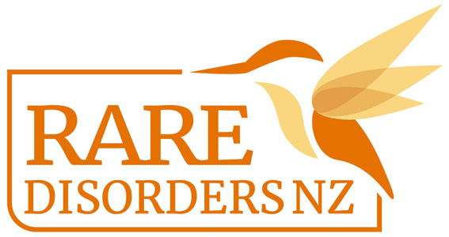
Social media captions |Rare Disorders Month School Kit

Use your own images from your Rare Disorders Month events, or select from one of our images and premade tiles.

Post caption 1

It’s not rare to have a rare disorder. In Aotearoa, more than 300,000 people live with one of 6,000 rare disorders - that’s the same as the population of Wellington.

March is Rare Disorders Month, a support period for the rare disorder community where Aotearoa is being called to Glow Up and Show Up for rare. As it stands in New Zealand, people living with a rare disorder are invisible in our healthcare system. Unlike most OECD countries, we don’t have a rare disorder strategy.

Glow up and Show up for Rare is all about shining a light on the urgent need for action in the Rare Disorders community. We stand with members of our school community affected by a rare disorder, and we’ll be getting involved in Rare Disorders Month by [insert activities].

Through raising money and maintaining visibility, together we can bring rare disorders out of the darkness, and into the light.

Visit raredisorders.org.nz and follow @RareDisordersNZ to see more on how to get involved.

#RareDisordersNZ #GlowUpShowUp

Post caption 2

We are proud of [insert school name]’s involvement across Rare Disorders Month which has taken place throughout March.

For Rare Disorders Month, Aotearoa was called to Glow Up and Show Up for rare. As it stands in New Zealand, people living with a rare disorder are invisible in our healthcare system. Unlike most OECD countries, we don’t have a rare disorder strategy.

Glow up and Show up for Rare is all about shining a light on the urgent need for action in the Rare Disorders community.

Throughout March, we were able to raise awareness by [list activities and events] and fundraised [insert $ amount] for Rare Disorders NZ.

Check out this picture of [insert image details. E.g. Room 6’s #GlowUpShowUp proudly wearing their Rare Disorders Month tattoos.]
Visit raredisorders.org.nz and follow @RareDisodersNZ to see more on how to get involved.

#RareDisordersNZ #GlowUpShowUp

