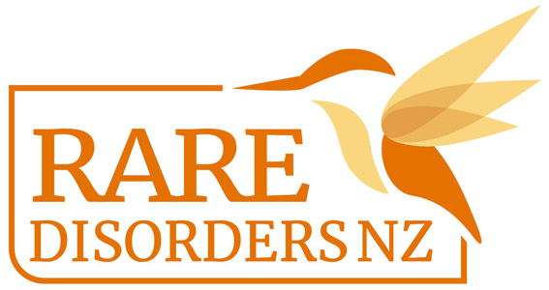

School Lesson Plan | Rare Disorders Month School Kit

PRIMARY LESSON - Year 0-6

Rare Disorders Month: Encouraging Inclusivity
Time : 40 minutes - 1 hour

Objectives | - Introduce a basic understanding of living with a rare disease to children  - Provoke empathy for children with a rare disease (or any chronic illness)  - Invite children to think about how they can include children with a rare disease
Lesson Overview | - Make reference to any previous activities that covered illness, disability or inclusion New learning and practice  - Read A Friendship Story with children  - Ask questions to help children to reflect on the story  - Answer any questions from the children  - Teach children about Rare Disorders Month  - Oversee creative exercise
Notes | Adapted from rarediseaseday.org, This lesson plan focuses on ‘A Friendship Story’ by Serbian author Danijela Pešić, also known by Danijela Knez, who herself lives with a rare disease (Pulmonary Hypertension--PH) and wrote this book inspired by her own childhood experiences. The disease featured in this story is not named and its symptoms are described in general terms, so that many children can relate to the story.  Consider inviting families with experience with a rare disease to come in and share their story too. You can also play videos that help explain what it’s like for people and families living with a given rare disease. These can complement the lesson and provide meaningful context.

Lesson Procedure
1. Read A Friendship Story with children [15 minutes] DOWNLOAD HERE
2. Ask questions to help children to reflect on the story
- Ask some or all of the questions below:
  - Why couldn’t Luke play outside with the other kids?
  - Luke has something called a rare disorder. What do you think a rare disorder is?
  - How do you think Luke felt when the other kids were playing outside without him?
  - Have you ever missed out on something because you were injured or felt sick?
  - Did you know that there are thousands of kids like Luke living with a rare disease that feel tired or sick, or can’t move their bodies the way other kids can?
    - Can you imagine how they are feeling?
    - How might their rare disorder affect their lives? (e.g trouble moving around, audio impaired, vision impaired, lots of days off school, more likely to get sick, inability to talk or walk)
  - What did you think of Steven’s surprise for Luke?
    - How do you think the surprise made Luke feel?
3. Answer any questions from the children, and invite the children to ask any questions they have
4. Teach the students about what a rare disorder is and about Rare Disorders Month using this key resources folder.
5. Creative exercise: in groups or pairs, ask the children to draw what it looks like to include other children living with a rare disorder, illness, or disability. Alternatively, you could brainstorm ideas as a class.
- E.g. playing an inside game instead of an outside game, helping other children to move around by opening doors for them or holding their belongings, spending time with other children if they aren’t able to participate in an activity, smiling and talking to children who might look or behave differently
6. Take a photo of the children holding up their images, and share some of the ideas the children came up with in your school newsletter, social media, or in an email home to parents. Include the line: “Visit raredisorders.org.nz, or follow @RareDisodersNZ on Facebook, LinkedIn and Twitter to see more on how to get involved. If you’re part of a rare disorder community, engage with your support group to find out more. #GlowUpShowUp #RareDisordersMonth”

INTERMEDIATE LESSON - Year 7-9

Rare Disorders Month: Raising Awareness

Objectives | - Raise awareness of rare disorders among students: both individual disorders and the realities of what patients face  - Improve research, writing, summarising, and presentation skills
Lesson Overview | - Introduce concept of Rare Disorders Month  - Show students videos that show reality of living with a rare disorder  - In groups or pairs, get students to conduct a research project on a rare disorder  - Get students to present their research back to the class
Notes | This lesson plan  Consider inviting families with experience with a rare disease to come in and share their story too. You can also play videos that help explain what it’s like for people and families living with a given rare disease. These can complement the lesson and provide meaningful context.

Lesson procedure
- Show students 1-2 videos showing real life experiences of people with rare disorders. Examples: here, here, here, and here
- Begin a class discussion about rare disorders to see what personal experience or prior knowledge the students have. Ask questions such as:
  - What do you already know about rare disorders?
  - Do you know of any rare disorders?
  - What do you think would be different about living with a rare disorder compared to living with a common disorder?
  - What kinds of challenges do you think people with rare disorders face?
- Teach the students about what a rare disorder is and about Rare Disorders Month using this key resources folder.
- Get students to research a rare disorder of their choice and present it back to the class. The presentation could be in the form of a speech, slide show, essay, poster, or video. The presentation should include:
  - Key information about the rare disorder. E.g. how many people are affected and how the disorder is contracted
  - What support and treatment is currently available in NZ for people living with this disorder, e.g. Rare Disorders NZ
  - The challenges people living with this disorder face
  - What the health system, the Government, and the general public could do to improve the lives of people living with this rare disorder and their families
- Take photos of the students doing their presentations, and share what the students achieved in your school newsletter, whānau communication platform, social media (if appropriate), or in an email home to parents. Include the line: “Visit raredisorders.org.nz, or follow @RareDisodersNZ on Facebook, LinkedIn and Twitter to see more on how to get involved. If you’re part of a rare disorder community, engage with your support group to find out more. #GlowUpShowUp #RareDisordersMonth”

