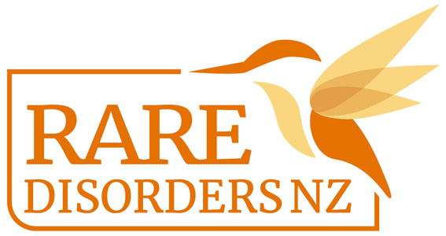

School Disco Guide | Rare Disorders Month School Kit

Hosting a disco during Rare Disorder Month is a great way to Glow Up and Show up for Rare Disorders. You could host this at school on International Rare Disorders Day, Feb 28, or sometime during Rare Disorders Month (March) that works for your school calendar.

- To align with the #GlowUpShowUp theme, encourage students to dress in bright or neon coloured clothes and accessories. You could have a prize for the student most committed to the theme.
- Send a note home to whānau including information about Rare Disorders Month and how families can get involved. Give details about the disco and any other events the school is organising for Rare Disorders Month.
- In the letter home, ask students who are able to bring a gold coin/koha for Rare Disorders NZ, or send a note to parents with a link to the RDNZ Givealittle page.
- Organise teachers and family volunteers to help out, including a DJ (perhaps a student or teacher with great playlists), face painters, donation collectors, catering, and extra hands.
  - Optional: Decorate your venue with bright, colourful decorations to fit with the #GlowUpShowUp theme. We recommend bright/neon lights, glow sticks, neon balloons, and streamers.
  - Provide face painting and glow sticks for students to help them glow up and show up. Neon face and body paints and glow sticks are available at Kmart, Spotlight, and The Warehouse. Fluro temporary tattoos are available from RDNZ for school discos. Make a request by emailing RDNZadmin@raredisorders.org.nz
- Editable posters are available for download here. Use this template to promote your disco.
- This disco day is also the perfect opportunity to also organise a colour run, Glow Up Day, or morning tea. You could also distribute our lesson plans to teachers, so students can learn about the cause behind the disco. Follow hyperlinks for templates and guides.
- Take a full school/class photo of students in their #GlowUpShowUp disco attire, and post it on your social media accounts, website, newsletters, and school yearbook. See our social media and newsletter templates here.
- After the disco contact RDNZadmin@raredisorders.org.nz to organise the transfer of donations and send in your photos.

Ngā mihi nui! We are so grateful for your support!

