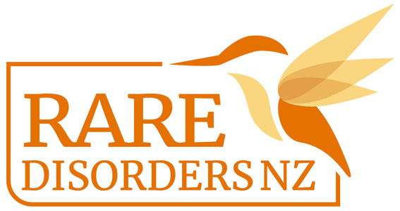
Morning Tea Guide |Rare Disorders Month School Kit

Holding a morning tea is also a great way to Glow Up and Show up for Rare Disorders. You could organise this on International Rare Disorders Day, Tuesday Feb 28, or sometime during Rare Disorders Month (March) that works for your school calendar.

- Organise a morning tea amongst students and/or staff where everyone brings a colourful plate to share to raise money and awareness for Rare Disorders Month.
- To align with the #GlowUpShowUp theme, encourage students and/or staff to don bright or neon coloured accessories.
- Ask students and/or staff to bring bright coloured food and drink, e.g. a rainbow shape of fresh fruit and veggies, fairy bread, or cupcakes with colourful icing.
- Send a note home to whānau including information about Rare Disorders Month and how families can get involved. Give details about the morning tea and any other events the school is organising for Rare Disorders Month.
- In the letter home, ask staff/students who are able to bring a gold coin/koha for Rare Disorders NZ, or send a note to parents with a link to the RDNZ Givealittle Page.
- Decorate your classroom or staff room with bright, colourful decorations to fit with the #GlowUpShowUp theme.
- Editable posters are available for download here. Use this template to promote your morning tea. And you can order tattoos for all attendees for your group photo op, by emailing RDNZadmin@raredisorders.org.nz.
- This morning tea is the perfect opportunity to also organise a colour run, Glow Up day, or disco on the same day. You could also distribute our lesson plans to teachers, so students can learn about the cause behind the morning tea. Follow hyperlinks for templates and guides.
- Take a staff/class photo of students in their #GlowUpShowUp attire, and post it on your social media accounts, website, newsletters, and school yearbook. See our social media and newsletter templates here.
- After the day, contact RDNZadmin@raredisorders.org.nz to arrange transfer of donations and send in your morning tea photos.

Ngā mihi nui! We are so grateful for your support!

