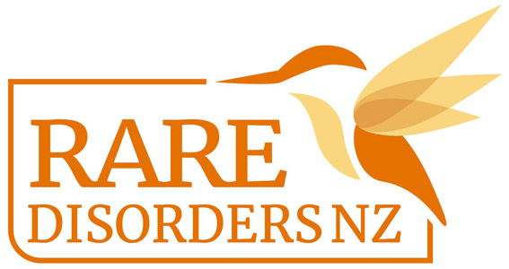

Glow Up Day Guide | Rare Disorders Month School Kit

A Glow Up clothing/accessory day is an opportunity for students to come to school wearing bright, colourful clothing or accessories instead of their usual uniform or regular clothing. You could run this event on International Rare Disease Day, Tuesday Feb 28, or sometime during Rare Disorders Month (March) that works for your school calendar.

- To align with the #GlowUpShowUp theme, encourage students to dress in bright or neon coloured clothes and accessories.
- Send a note home to parents including information about Rare Disorders Month and how families can get involved. Give details about the Glow Up clothing/accessory day and any other events the school is organising to get involved.
- In the note home, ask students who are able to bring a gold coin/koha for Rare Disorders NZ, or send a note to parents with a link to the RDNZ givealittle page.
- Incorporate face painting and glow sticks into the day to help students glow up and show up. Neon face and body paints and glow sticks are available at Kmart, Spotlight, and The Warehouse. Fluro temporary tattoos are available from RDNZ for school Glow Up clothing/accessory days. Make a request by emailing RDNZadmin@raredisorders.org.nz
- Editable posters are available for download here. Use this template to include information about your own Glow Up day.
- This Glow Up clothing/accessory day is the perfect opportunity to also organise a colour run, disco, or morning tea. You could also distribute our lesson plan to teachers, so students can learn about the cause behind the Glow Up clothing/accessory day. Follow hyperlinks for templates and guides.
- Take a full school/class photo or students in their #GlowUpShowUp attire, and post it on your social media accounts, website, newsletters, whānau communication platforms and school yearbook. See our social media and newsletter templates you are welcome to use.
- After the day, you can contact RDNZadmin@raredisorders.org.nz to organise the transfer of donations and send in your Glow Up day photos.

Ngā mihi nui! We are so grateful for your support!

