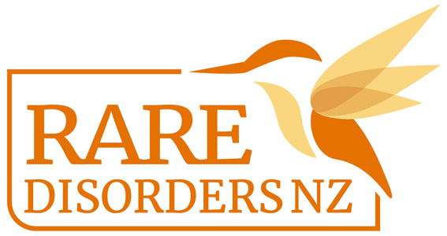
Colour Run Guide | Rare Disorders Month School Kit

Organising a colour run during Rare Disorders Month is a great way to help students glow up and show up for rare disorders. It’s also a fun outdoor activity before summer draws to a close. The Colour Run is inspired by the Hindu Holi Festival.

- Send a note home to parents including information about Rare Disorders Month and how families can get involved. See this letter template for reference. Give details about the colour run and any other events the school is organising to get involved.
- Ask students to bring old clothes they feel comfortable running in and getting paint on. To align with the #GlowUpShowUp theme, encourage students to dress in bright or neon coloured clothes and accessories where possible.
- In the note home, ask students who are able to bring a gold coin/koha for Rare Disorders NZ, or send a note to parents with a link to the RDNZ Givealittle page.
- Editable posters are available for download here. Use this template to include information about your own colour run.
- A colour run is usually 5km, but this could be adjusted depending on age and ability. Set up stations around the run where teachers and volunteers can throw the paint powder on students.
- You could incorporate a colour run into an existing school event, like a house competition or athletics day.
- You may have leftover powder paint from other colour run events. Otherwise, powder paint is available from Creative Classrooms and holipowder.nz.
- A colour run is the perfect opportunity to also organise a Glow Up day, disco, or morning tea. You could also distribute our lesson plan to teachers, so students can learn about the cause behind the colour run. Follow hyperlinks for templates and guides.
- Take a full school/class photo of students in their post-colour run #GlowUpShowUp attire, and post it on your social media accounts, website, newsletters, and school yearbook. See our social media and newsletter templates here.
- After the event contact RDNZadmin@raredisorders.org.nz to organise transfer of donations and send in your photos.

Ngā mihi nui! We are so grateful for your support!

